Cromwell_Lesson Plan2 CTA Middle School APE Personal Fitness
Assessments may occur at any time during the lesson and should be noted in the appropriate section of the lesson; supporting assessment or lesson documents may be attached as a separate page.
Learning Objective: I can do 3 exercises safely and help my body get stronger (heart & muscles). | Lesson Notes/materials: 3 different Cardiovascular exercise machines (rowing, stationary bike, treadmill) or 3 exercises (run/walk, step box, Jump Rope) Poster of Intensity Levels, Timer, Pulse Monitor Baton, and Fitness Log Sheet.
SOL: 4.3d: 4.3d Identify activities that can be done at school and activities that can be done at home to meet fitness goals. , 5.3ff) Explain the relationship between heart rate and cardiorespiratory fitness, 6.3dd) Describe how being physically active leads to a healthy body, 7.3aa) Identify safe practices for improving physical fitness, 8.3cc) Demonstrate use of technology tools to assess, monitor/record, and improve personal fitness, 9.3cc) Explain the characteristics, including scientific principles and concepts, of safe and appropriate muscular-stretching, muscular-strengthening, and cardiorespiratory exercise programs to improve the health-related components of fitness.
Link to Background Knowledge
What is the background knowledge that students need to meet the learning objective? Students have been taught how to use the machines or do the exercises correctly. The information on the intensity poster has been taught previously. This lesson is to help reinforce the concept of safety and the need to exercise to keep the body strong.
May include pre-assessment or review of previous instruction.
Engage and Explain
What is the knowledge or skill that students will need to be successful in meeting the learning objective?
Each student takes a turn on a cardio machine for 10 minutes (recording heart rate before and after with a pulse bar, and pointing to the cardio level pictures to describe how they feel) Rowing machine makes arms and legs stronger and heart beat faster. Stationary bike helps legs get stronger by pedaling and heart stronger by beating faster. The treadmill needs to be used within a safe range of numbers (2.5-4) so students do not fall off and hurt themselves (bruises or broken bones) the treadmill has numbers taped above the speed display so students can match the speed. The treadmill helps make your legs and heart get strong.
Active Learning
How will students apply the new knowledge? They should be able to enter a fitness facility in the community and recognize the equipment and how to use it safely. This is a life long skill that can be continued outside of the school environment with friends, family, or on their own. The students recognize levels of the machines and the speeds at which they are going. They count their number of rows on the rowing machine, and use the treadmill timer and speed settings to gauge how fast and how long they are to keep going. As they are walking and riding they talk about what they had for lunch and the healthy elements of the food they eat. They also talk about the muscles they use while on the different machines.
What will you do for students who have early success? Students with early success can calculate a working and resting heart rate and move faster or slower on the pieces of equipment to maintain a certain rate or achieve that rate during each workout on the various pieces of equipment. Students can help others to remain safe and encourage them to work harder and faster to get stronger quicker. They demonstrate proper technique and are good role models for their peers. | What will you do for students who need additional support (special needs, EL, or more time/practice)? Picture instructions for each piece of equipment can help provide support and guidance, Speeds can be adjusted for their current fitness and ability levels. Peer helpers to encourage and participate along with the students to 'race' or keep pace with the student. A student in a wheelchair can move a rod or weight in the motion of the rowing machine to simulate rowing, they can move their legs up and down in their chair to simulate walking on the treadmill (or if they have a gait trainer they can walk on the floor instead of the treadmill, they could also use a stationary bike pedal from their chair, or use their arms in a circular motion of pedaling.
Reflect
How will students connect new learning to previous learning? They have their exercise log and will enter the distance walked, biked, and the number of rows they did on the rowing machine. Looking at the sheet they can compare how they feel today to previous days and set goals for next time they use the machines. How will students make connections? They can talk about when they may ride a bike at home, walk on the track, or to a friends house, and if they might use their arms to row a boat, or other arm exercises or games. | Assessment: How will students know if they got it? Student will be able to get on, turn on, and make the cardio machine work keeping it within the acceptable ranges. There are consequences if they are unsafely using the equipment, and rewards for when their chart is filled. How will teacher know if students got it? The student will be able to safely participate and fill in the appropriate record sheet.
Next Steps
What is the real world application for this new learning? Being physically active is a life long habit. Students are trying to develop independence and the ability to stay active as they get more independent. How does it connect to future learning? Hopefully the knowledge and practice will help them to want to continue to seek exercise opportunities in the future.

INCLUDE: Fitness Log Sheet, Intensity levels poster,
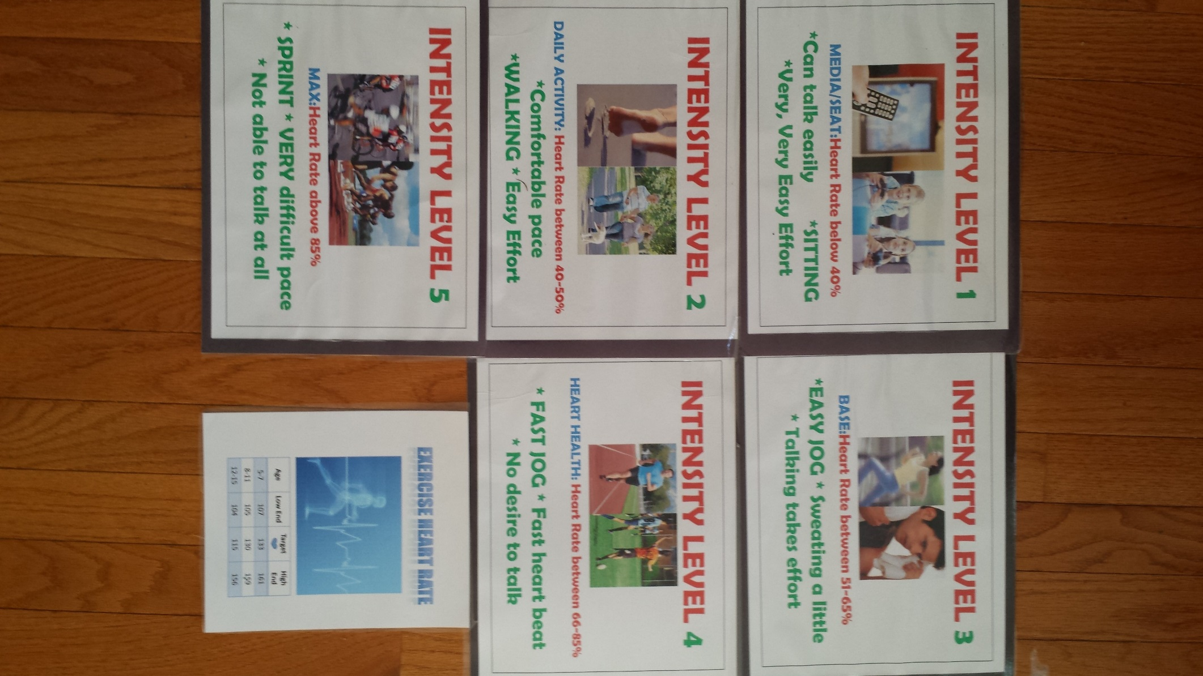

Fitness Log
Name | Date | Date | Date | Date | Date | Summary
Bike

Distance
Rowing

# of Rows
Treadmill

Distance
Walk or Run

Distance

Or Time
How Did You Feel?
1,2,3,4,5?
How hard did you workout?

Game Activity

How Did You Feel Today?

